**Experiment -2**

**MCQ:**

1. Consider a gray scale image which is added to its negative image. Then all pixels in the resulting image will have value=

a) 0 b) 100 c) 255 d)256

Answer: c)

2. Which expression is obtained by performing the negative transformation on the negative of

an image with gray levels in the range[0,L-1] ?

a) s=L+1-r

b) s=L+1+r

c) s=L-1-r

d) s=L-1+r

Answer: a)

Assignment 1:

clc;

clear all;

close all;

I=imread('red_flower.png');

G=rgb2gray(I);

Inverted=255-G;

figure

imshow(G)

figure

imshow(Inverted)

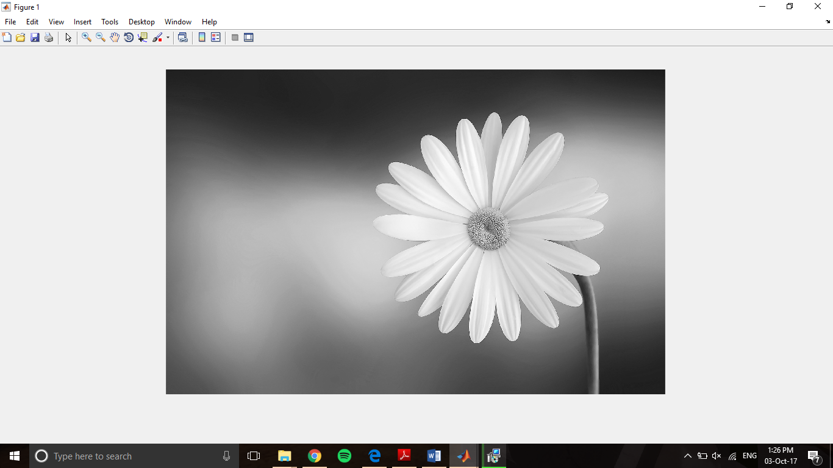

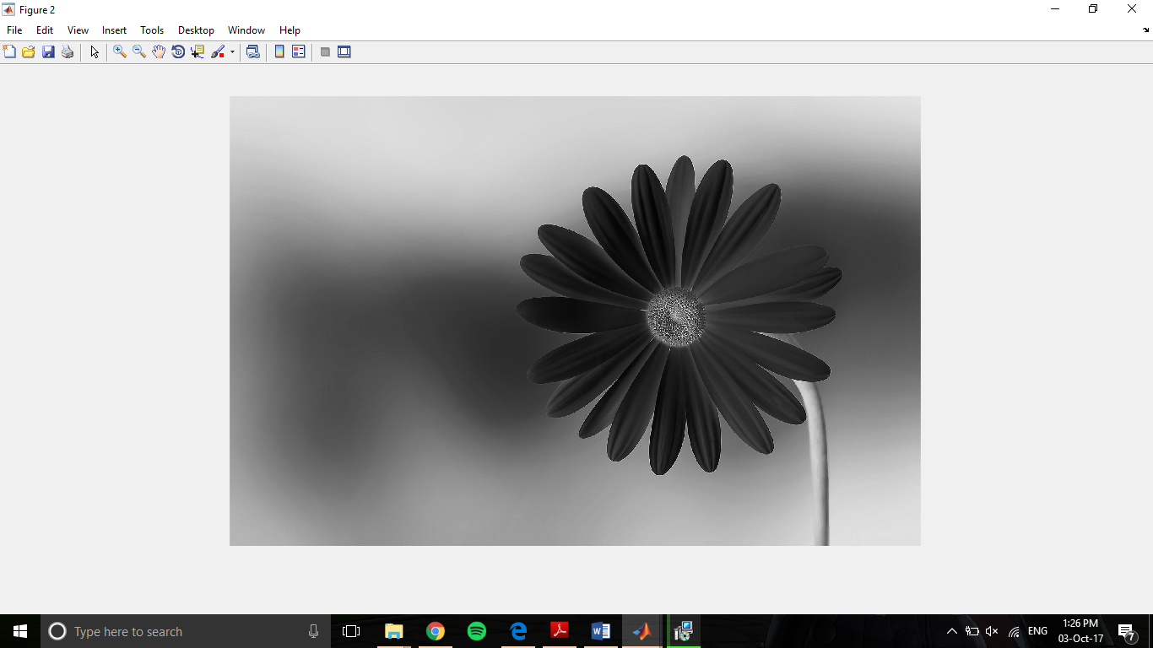

**MCQ:**

1. Consider a gray scale image ‘A’ and its negative image ‘B’, the histogram of negative image is related to histogram of original image as:

a) Same as that of A

b) Mirror image about horizontal axis

c) Mirror image about the vertical axis

d) No relation

2. What is the method that is used to generate a processed image that have a specified histogram?

a) Histogram linearization

b) Histogram equalization

c) Histogram matching

d) Histogram processing

3. In a dark image, the components of histogram are concentrated on which side of the grey scale?

a) High

b) Medium

c) Low

d) Evenly distributed

Answers: 1. (b)

2. (b) In image processing, histogram matching or histogram specification is the transformation of an image so that its histogram matches a specified histogram. The well-known histogram equalization method is a special case in which the specified histogram is uniformly distributed.

3. (c)

Assignment – 2

clc;

clear all;

close all;

I=imread('red_flower.png');

G=rgb2gray(I);

figure

imhist(G);

figure

imshow(G)

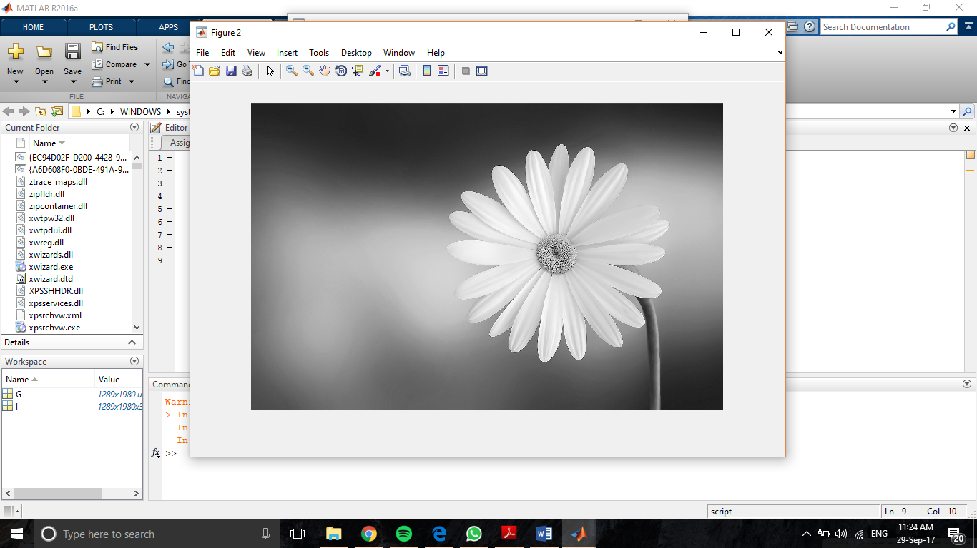

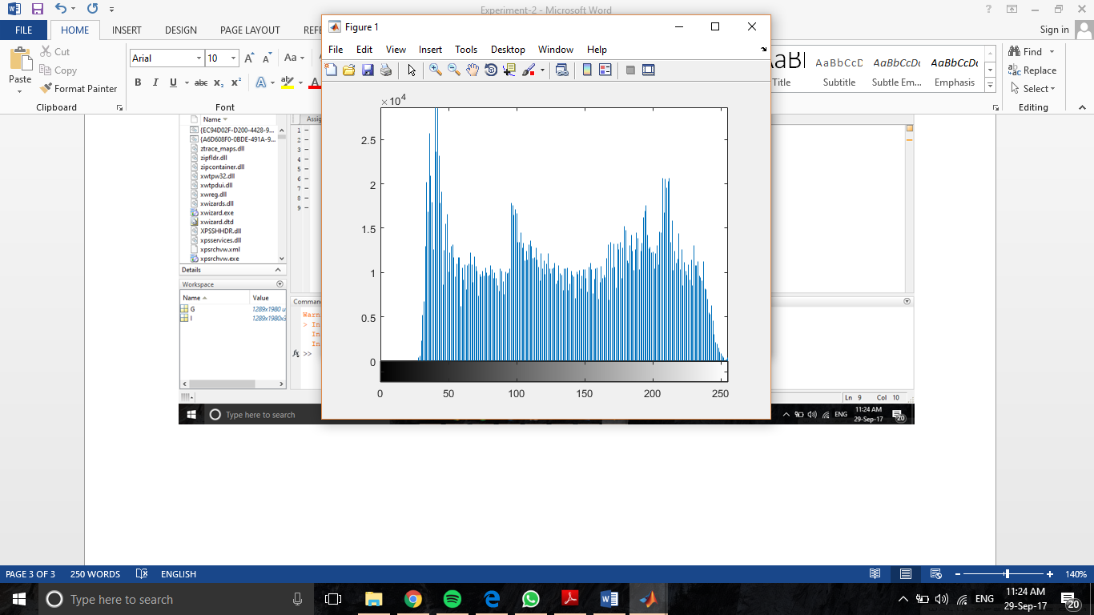

Assignment - 3

clc;

clear all;

close all;

I=imread('red_flower.png');

G=rgb2gray(I);

figure

subplot(211)

imhist(G)

subplot(212)

imshow(G);

H = histeq(G);

figure

subplot(211)

imhist(H)

subplot(212)

imshow(H)

J=imadjust(G);

figure

subplot(211)

imhist(J)

subplot(212)

imshow(J)

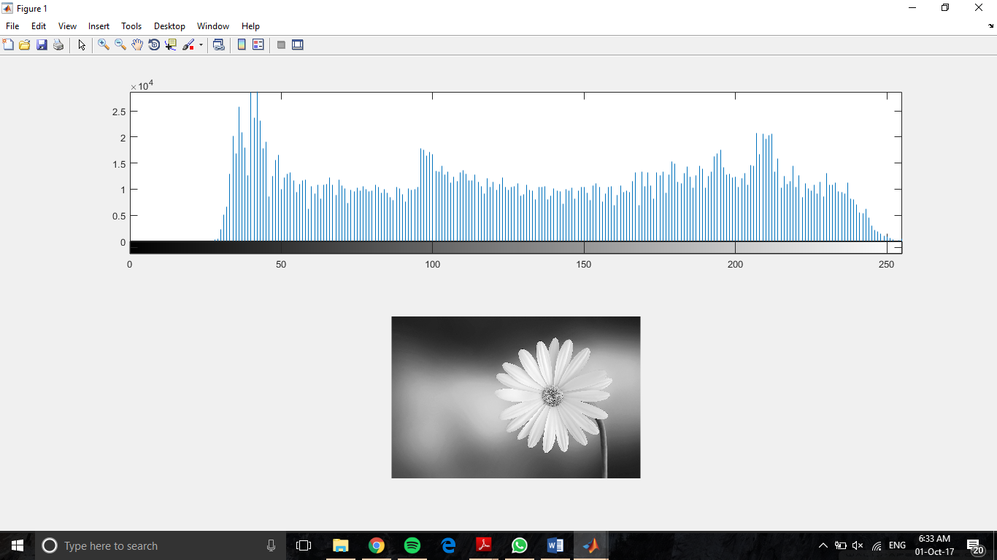

USING HISTEQ:

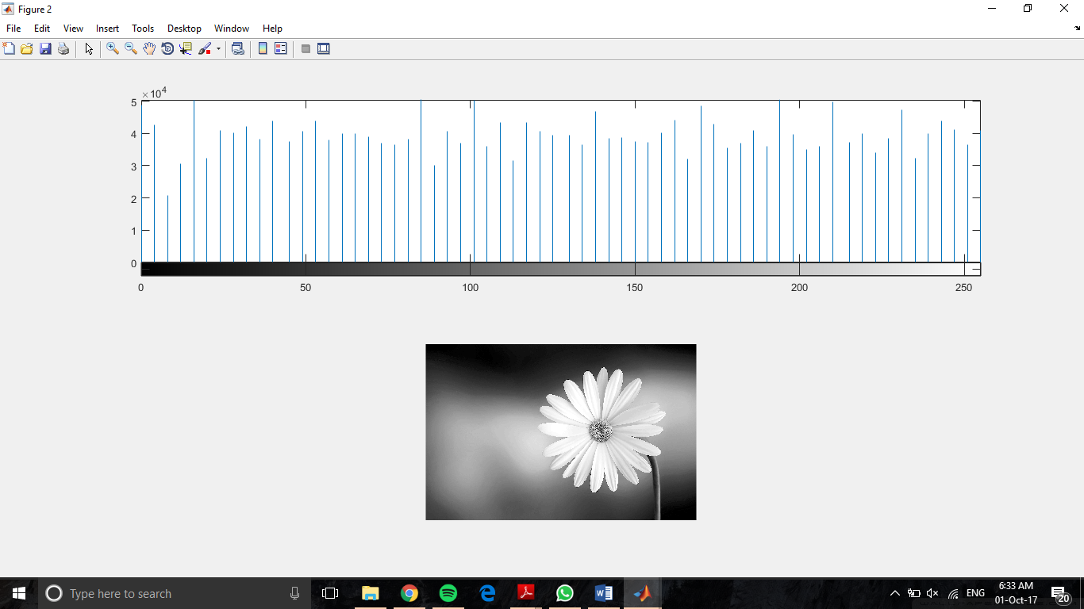

USING IMADJUST:

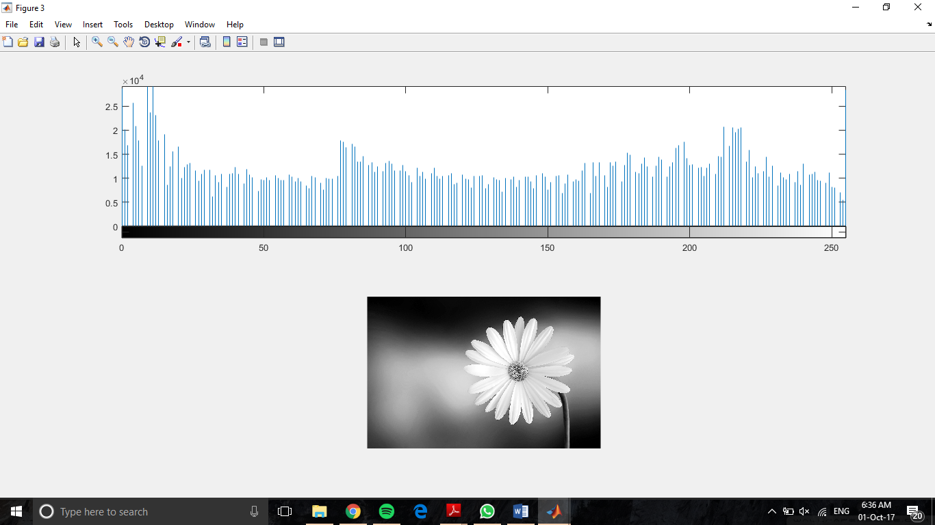

1. Image processing approaches operating directly on pixels of input image work directly in ____________

a) Transform domain

b) Spatial domain

c) Inverse transformation

d) None of the Mentioned

2. The subtraction operation results in areas that appear as dark shades of gray. Why?

a) Because the difference in such areas is little, that yields low value

b) Because the difference in such areas is high, that yields low value

c) Because the difference in such areas is high, that yields high value

d) None of the mentioned

3. If the images are displayed using 8-bits, then, what is the range of the value of an image if the image is a result of subtraction operation?

a) 0 to 255

b) 0 to 511

c) -255 to 0

d) None of the mentioned

4. The subtracted image needs to be scaled, if 8-bit channel is used to display the subtracted images. So, the method of adding 255 to each pixel and then dividing by 2, has certain limits. What is/are those limits?

a) Very complex method

b) Very difficult to implement

c) The truncation inherent in division by 2 causes loss in accuracy

d) All of the above

Answers:

1. (B)
2. (B)
3. (A)
4. (C) In numerical analysis and scientific computing, truncation error is the error made by truncating an infinite sum and approximating it by a finite sum. It is present even with infinite-precision arithmetic, because it is caused by truncation of the infinite Taylor series to form the algorithm. Often, truncation error also includes discretization error, which is the error that arises from taking a finite number of steps in a computation to approximate an infinite process.

Assignment – 4

clc;

clear all;

close all;

X = uint8([ 45 40 50 60 30 70 45 0 62 255 100 255 0 75; 60 30 70 45 255 100 44 225 100 35 20 78 90 100]);

Y = uint8([ 0 1 1 0 1 0 1 1 1 1 1 0 0 0; 0 1 1 0 0 0 0 1 0 1 1 1 1 1]);

A = imadd(X,Y);

B = imsubtract(X,Y);

C = immultiply (X,Y);

figure

subplot (311)

imshow(A);

subplot (312)

imshow(B);

subplot (313)

imshow(C);

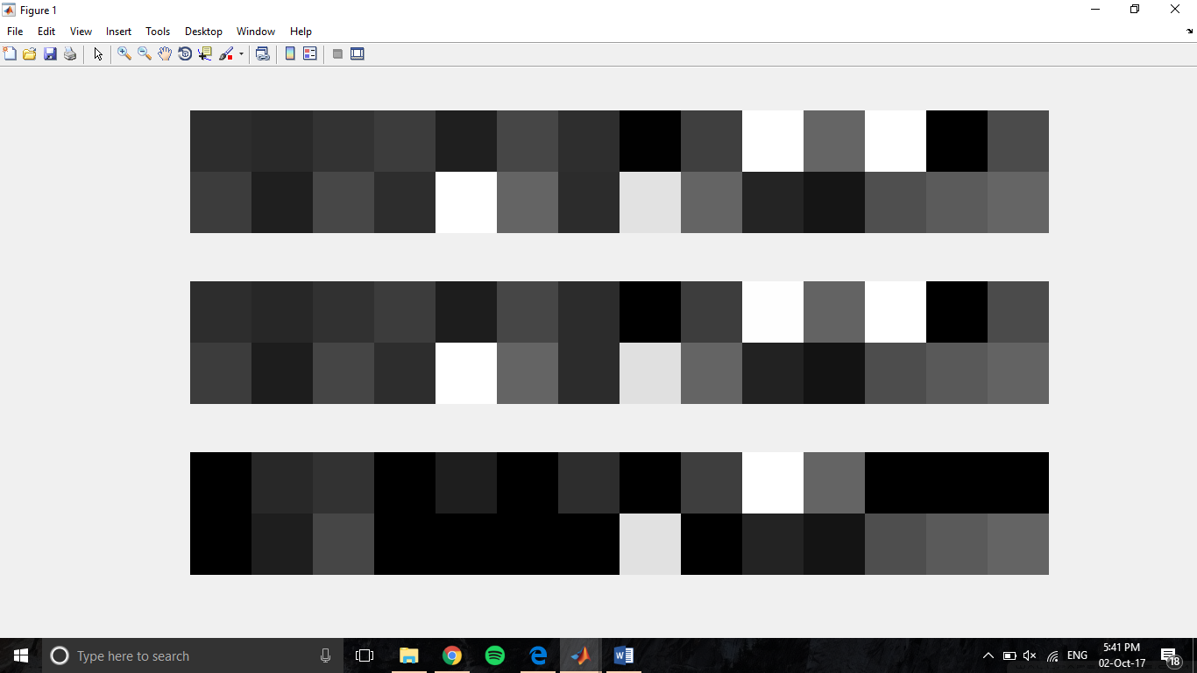

MCQ

1. Which of the following shows three basic types of functions used frequently for image enhancement?

a) Linear, logarithmic and inverse law

b) Power law, logarithmic and inverse law

c) Linear, logarithmic and power law

d) Linear, exponential and inverse law

2. What is the general form of representation of log transformation?

a) s = clog10(1/r)

b) s = clog10(1+r)

c) s = clog10(1*r)

d) s = clog10(1-r)

3. What is the name of process used to correct the power-law response phenomena?

a) Beta correction

b) Alpha correction

c) Gamma correction

d) Pie correction

4. Dark characteristics in an image are better solved using ____________________.

a) Laplacian Transform

b) Gaussian Transform

c) Histogram Specification

d) Power-law Transformation

Answers

1. (c)
2. (b) The log transformations can be defined by this formula

s = c log(r + 1).

Where s and r are the pixel values of the output and the input image and c is a constant. The value 1 is added to each of the pixel value of the input image because if there is a pixel intensity of 0 in the image, then log (0) is equal to infinity. So 1 is added, to make the minimum value at least 1.

During log transformation, the dark pixels in an image are expanded as compare to the higher pixel values. The higher pixel values are kind of compressed in log transformation. This result in following image enhancement.

The value of c in the log transform adjust the kind of enhancement you are looking for.

1. (c)
2. (d) Gamma correction is used

Assignment – 5

clc;

clear all;

close all;

I=imread('red_flower.png');

G=rgb2gray(I);

r = double(G)/255; % normalise the image

c =1.5;

gamma=[0.5,1.5,3]; % to make image dark take value of gamma > 1, to make image bright take vlue of gamma < 1

s1=(c*(r)).^gamma(1);

s2=(c*(r)).^gamma(2);

s3=(c*(r)).^gamma(3);

figure

subplot(2,2,1),imshow(uint8(G)),title('Original Image');

subplot(2,2,2),imshow(s1),title('Power Law Transformed Image for gamma=0.5');

subplot(2,2,3),imshow(s2),title('Power Law Transformed Image for gamma=1.5');

subplot(2,2,4),imshow(s3),title('Power Law Transformed Image for gamma=3');

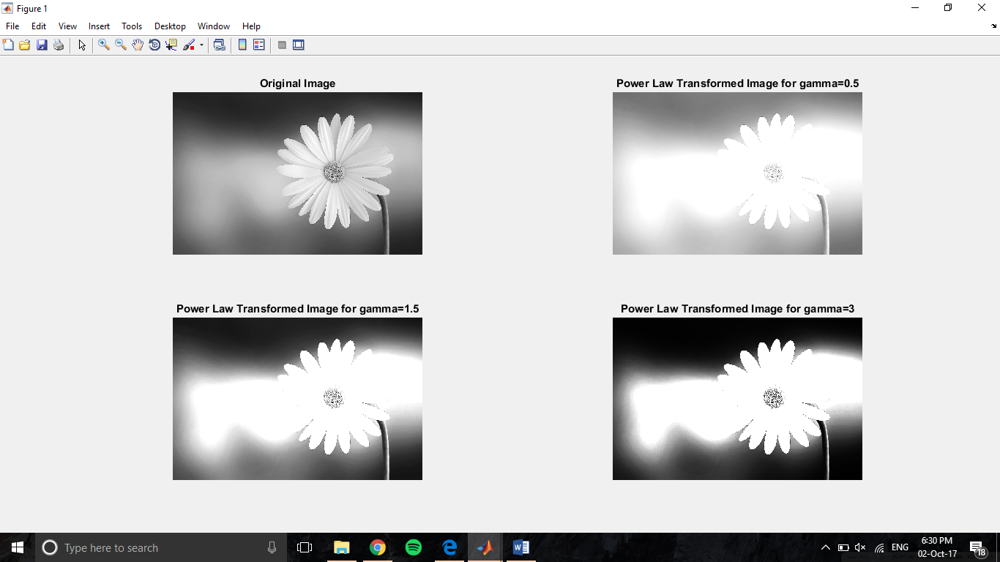

References

1. <http://in.mathworks.com/help/images/ref/histeq.html>
2. <https://in.mathworks.com/help/images/ref/imadd.html>
3. <https://www.tutorialspoint.com/dip/gray_level_transformations.htm>
4. <http://www.sanfoundry.com/digital-image-processing-mcqs-spatial-enhancements-methods/>